Source Data Mapping Approach to CDMV6.0

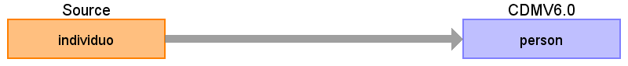

Table name: person

Reading from individuo

select

sihosp.get_cns_pessoa(pessoa.seq_pessoa) cns,

pessoa.nom_pessoa nome,

pessoa.nom_mae nome_mae,

case when pessoa.cod_sexo ='M' then 'MASCULINO'

when pessoa.cod_sexo ='F' then 'FEMININO'

else 'IGNORADO' end sexo,

etnia.nom_etnia raca,

pessoa.dat_nascimento data_nascimento,

pais.nom_pais pais_nascimento,

case when pessoa.seq_pais = 1

then municipio.nom_municipio end municipio_nascimento,

pais.seq_pais pais_residencia,

endereco.seq_municipio municipio_residencia,

pessoa.seq_pessoa seq_pessoa

from pessoa

inner join etnia ON etnia.seq_etnia = pessoa.seq_etnia_pessoa

inner join municipio on ( municipio.seq_municipio = pessoa.seq_municipio and

municipio.seq_pais = pessoa.seq_pais )

inner join pais on pessoa.seq_pais = pais.seq_pais

inner join endereco ON endereco.seq_pessoa = pessoa.seq_pessoa

where sihosp.get_cns_pessoa(pessoa.seq_pessoa) is not null

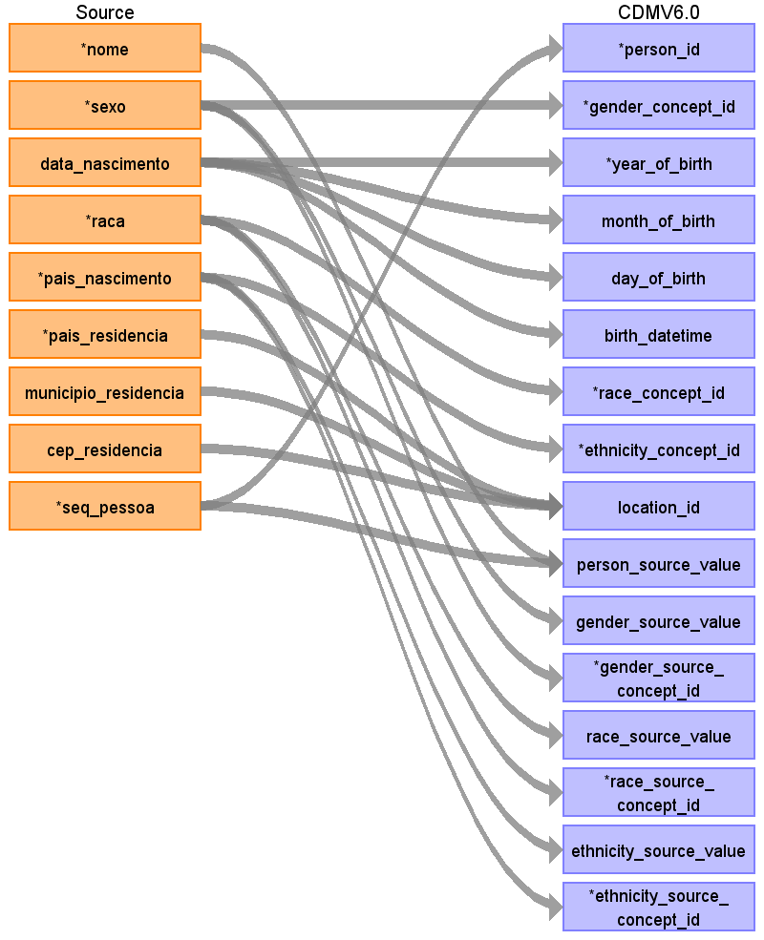

|  |  |  |  |
| --- | --- | --- | --- |
| Destination Field | Source Field | Logic | Comment |
| person_id | seq_pessoa |  |  |
| gender_concept_id | sexo |  |  |
| year_of_birth | data_nascimento |  |  |
| month_of_birth | data_nascimento |  |  |
| day_of_birth | data_nascimento |  |  |
| birth_datetime | data_nascimento |  |  |
| death_datetime |  |  |  |
| race_concept_id | raca |  |  |
| ethnicity_concept_id | pais_nascimento |  |  |
| location_id | pais_residencia  municipio_residencia  cep_residencia |  |  |
| provider_id |  |  |  |
| care_site_id |  |  |  |
| person_source_value | nome  seq_pessoa |  |  |
| gender_source_value | sexo |  |  |
| gender_source_concept_id | sexo |  |  |
| race_source_value | raca |  |  |
| race_source_concept_id | raca |  |  |
| ethnicity_source_value | pais_nascimento |  |  |
| ethnicity_source_concept_id | pais_nascimento |  |  |

Table name: observation_period

Table name: visit_occurrence

Table name: visit_detail

Table name: condition_occurrence

Table name: procedure_occurrence

Table name: drug_exposure

Table name: device_exposure

Table name: measurement

Table name: observation

Table name: specimen

Table name: note

Table name: note_nlp

Table name: survey_conduct

Table name: cost

Table name: payer_plan_period

Table name: drug_era

Table name: dose_era

Table name: condition_era

Table name: location

Table name: location_history

Table name: provider

Table name: care_site

Table name: cdm_source

Table name: metadata

Table name: fact_relationship

Appendix: source tables

Table: diagnostico

|  |  |  |  |
| --- | --- | --- | --- |
| Field | Type | Most freq. value | Comment |
| terminologia | character varying | CID-10 |  |
| versao | character varying | 2.16.840.1.113883.6.3 |  |
| problema | character varying |  |  |
| indicador_admissao | character varying | Não |  |
| categoria | character varying | Principal |  |

Table: contato_assistencial

|  |  |  |  |
| --- | --- | --- | --- |
| Field | Type | Most freq. value | Comment |
| estabelecimento_saude | character varying | 2025507 |  |
| dados_admissao | character varying | de |  |
| data_admissao | date | 2020-01-23 |  |
| procedencia | integer | 12 |  |
| modalidade | character varying | AMBULATORIO |  |
| carater | character varying | ELETIVO |  |
| dados_desfecho | character varying | RETORNO |  |
| motivo_desfecho | character varying | RETORNO |  |
| data_desfecho | date | 2020-09-15 |  |
| seq_pessoa | integer |  |  |

Table: procedimentos

|  |  |  |  |
| --- | --- | --- | --- |
| Field | Type | Most freq. value | Comment |
| financiamento | character varying | 01 |  |
| terminologia | character varying | Tabela SUS |  |
| versao | character varying | 2.16.840.1.113883.2.21.1.121 |  |
| procedimento | character varying | 0301010072 |  |
| quantidade | integer | 1 |  |
| data_realizacao | date | 2020-12-10 |  |
| autorizacao | integer | 4924051 |  |
| cbo | character varying | 225265 |  |
| cns | character varying |  |  |
| estabelecimento_terceiro | character varying |  |  |
| equipe_terceira | character varying |  |  |

Table: individuo

|  |  |  |  |
| --- | --- | --- | --- |
| Field | Type | Most freq. value | Comment |
| cns | character varying | 709204259996130 |  |
| justificativa_impossibilidade | character varying |  |  |
| nome | character varying | MARIA APARECIDA DA SILVA |  |
| nome_mae | character varying | MARIA APARECIDA DA SILVA |  |
| sexo | character varying | FEMININO |  |
| data_nascimento | date |  |  |
| raca | character varying | BRANCA |  |
| pais_nascimento | character varying | BRASIL |  |
| municipio_nascimento | character varying | MARILIA |  |
| pais_residencia | integer | 1 |  |
| municipio_residencia | integer | 3584 |  |
| cep_residencia | integer |  |  |
| seq_pessoa | integer |  |  |